
Careers Behind the Cameras: Amazon MGM Studios
Note Catcher
Name Class

The Big Question:
How do people use math and technology to turn a TV show or movie idea into a reality?

Directions: During each stop on the tour, match the new vocabulary word with its definition using the word bank below. At the end of each stop, reflect on what you learned about our investigation question.
software mood hardware system Artificial Intelligence game engine previsualization

Stop | Vocabulary | Facts I learned at this stop/  Questions I still have
Introduction   | Artificial Intelligence: Computer systems that can perform tasks typically done by humans by learning from data. (Video 2)  system: A group of parts working together to accomplish a task. (Video 2)
Stop 1  Previsualization  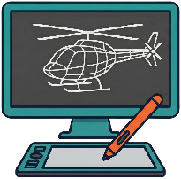 | previsualization: An animated version of movie scenes used to explore ideas and creative concepts before filming begins. (Video 3)  mood: The feeling or emotion you want the audience to have when they’re watching. (Video 3)
Stop 2  Virtual Production  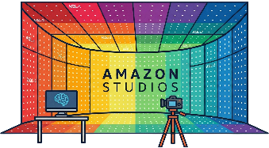 | hardware: The physical parts of the computer system. (Video 4)  software: The instructions given to a computer. (Video 4)  game engine: A computer program used to build and run 3D interactive environments. (Video 4)
Careers Behind the Cameras: Amazon MGM Studios Notecatcher

data analytics cloud computing frame ratio Generative AI timecode

Stop | Vocabulary | Facts I learned at this stop/  Questions I still have
Stop 3  Post-Production  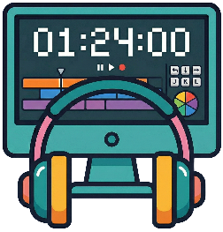 | timecode: A digital clock that tracks hours, minutes, seconds, and frames in a video. (Video 5)  frame: A single image in a video. (Video 5)
Stop 4  Marketing   | data analytics: The process of examining numbers to find patterns that help to make better decisions. (Video 6)  ratio: Comparing numbers to show their relative values. (Video 6)
Stop 5    Innovation | cloud computing : Securely storing and sharing data over the internet instead of using physical drives. (Video 7)  Generative AI : Artificial Intelligence that can create new content and ideas based on user prompts. (Video 7)

To explore more careers, visit http://amazonfutureengineer.com

