
AWS Data Center Tour 1:
Uncovering Cloud Computing
Note Catcher
Name Class
The Big Question:
How do data centers help me access information from wherever and whenever I want?
Directions: At each stop on the tour, match the new vocabulary word with its definition using the word bank below. At the end of each stop, reflect on what you learned about our investigation question.
input storage server cloud computing protocol internet URL
DNS processing fiber optic cable output data centers IP address

Stop | Vocabulary | Facts I learned at this stop/  Questions I still have
‘Ancient’ Technology


Computers as  Systems  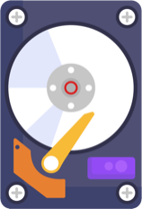 | : information that is entered into or received by  a computer (Slide 7)  : the thinking work a computer does to turn an input into an output (Slide 9)  :  saving information on a physical device so it can be used later (Slide 9)  :  the information computers give to users, devices, or other computers, i.e. video, sound, images (Slide 9)

AWS Data Center Tour 1: Uncovering Cloud Computing Note Catcher

input storage server cloud computing protocol internet URL
DNS processing fiber optic cable output data centers IP address

Stop | Vocabulary | Facts I learned at this stop/  Questions I still have
Cloud Computing  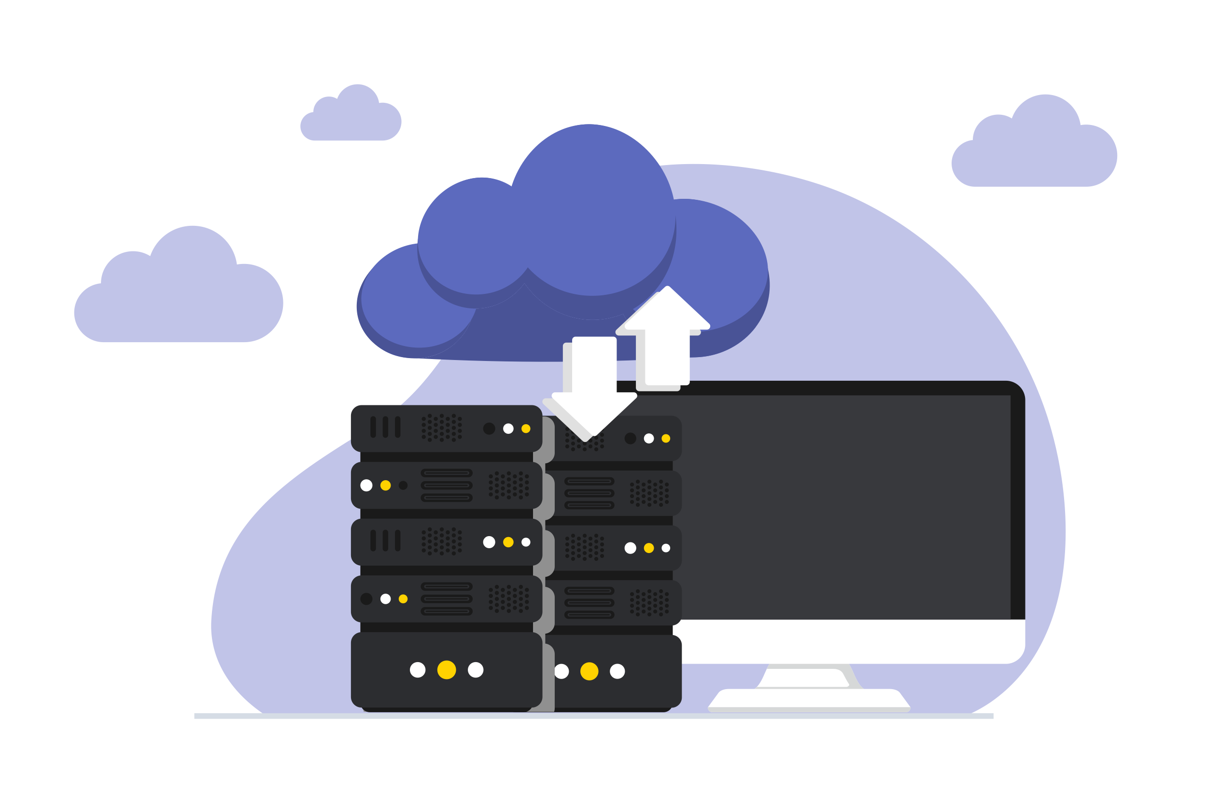 | : giant warehouses that house thousands of processing and storage devices (Slide 15)  : a network of computer networks that can exchange information between devices (Slide 15)  : a computer whose function is to store, process, send, or receive data (Slide 15)  : the delivery of technology resources – including storage and processing – through the Internet (Slide 17)
Passing Information  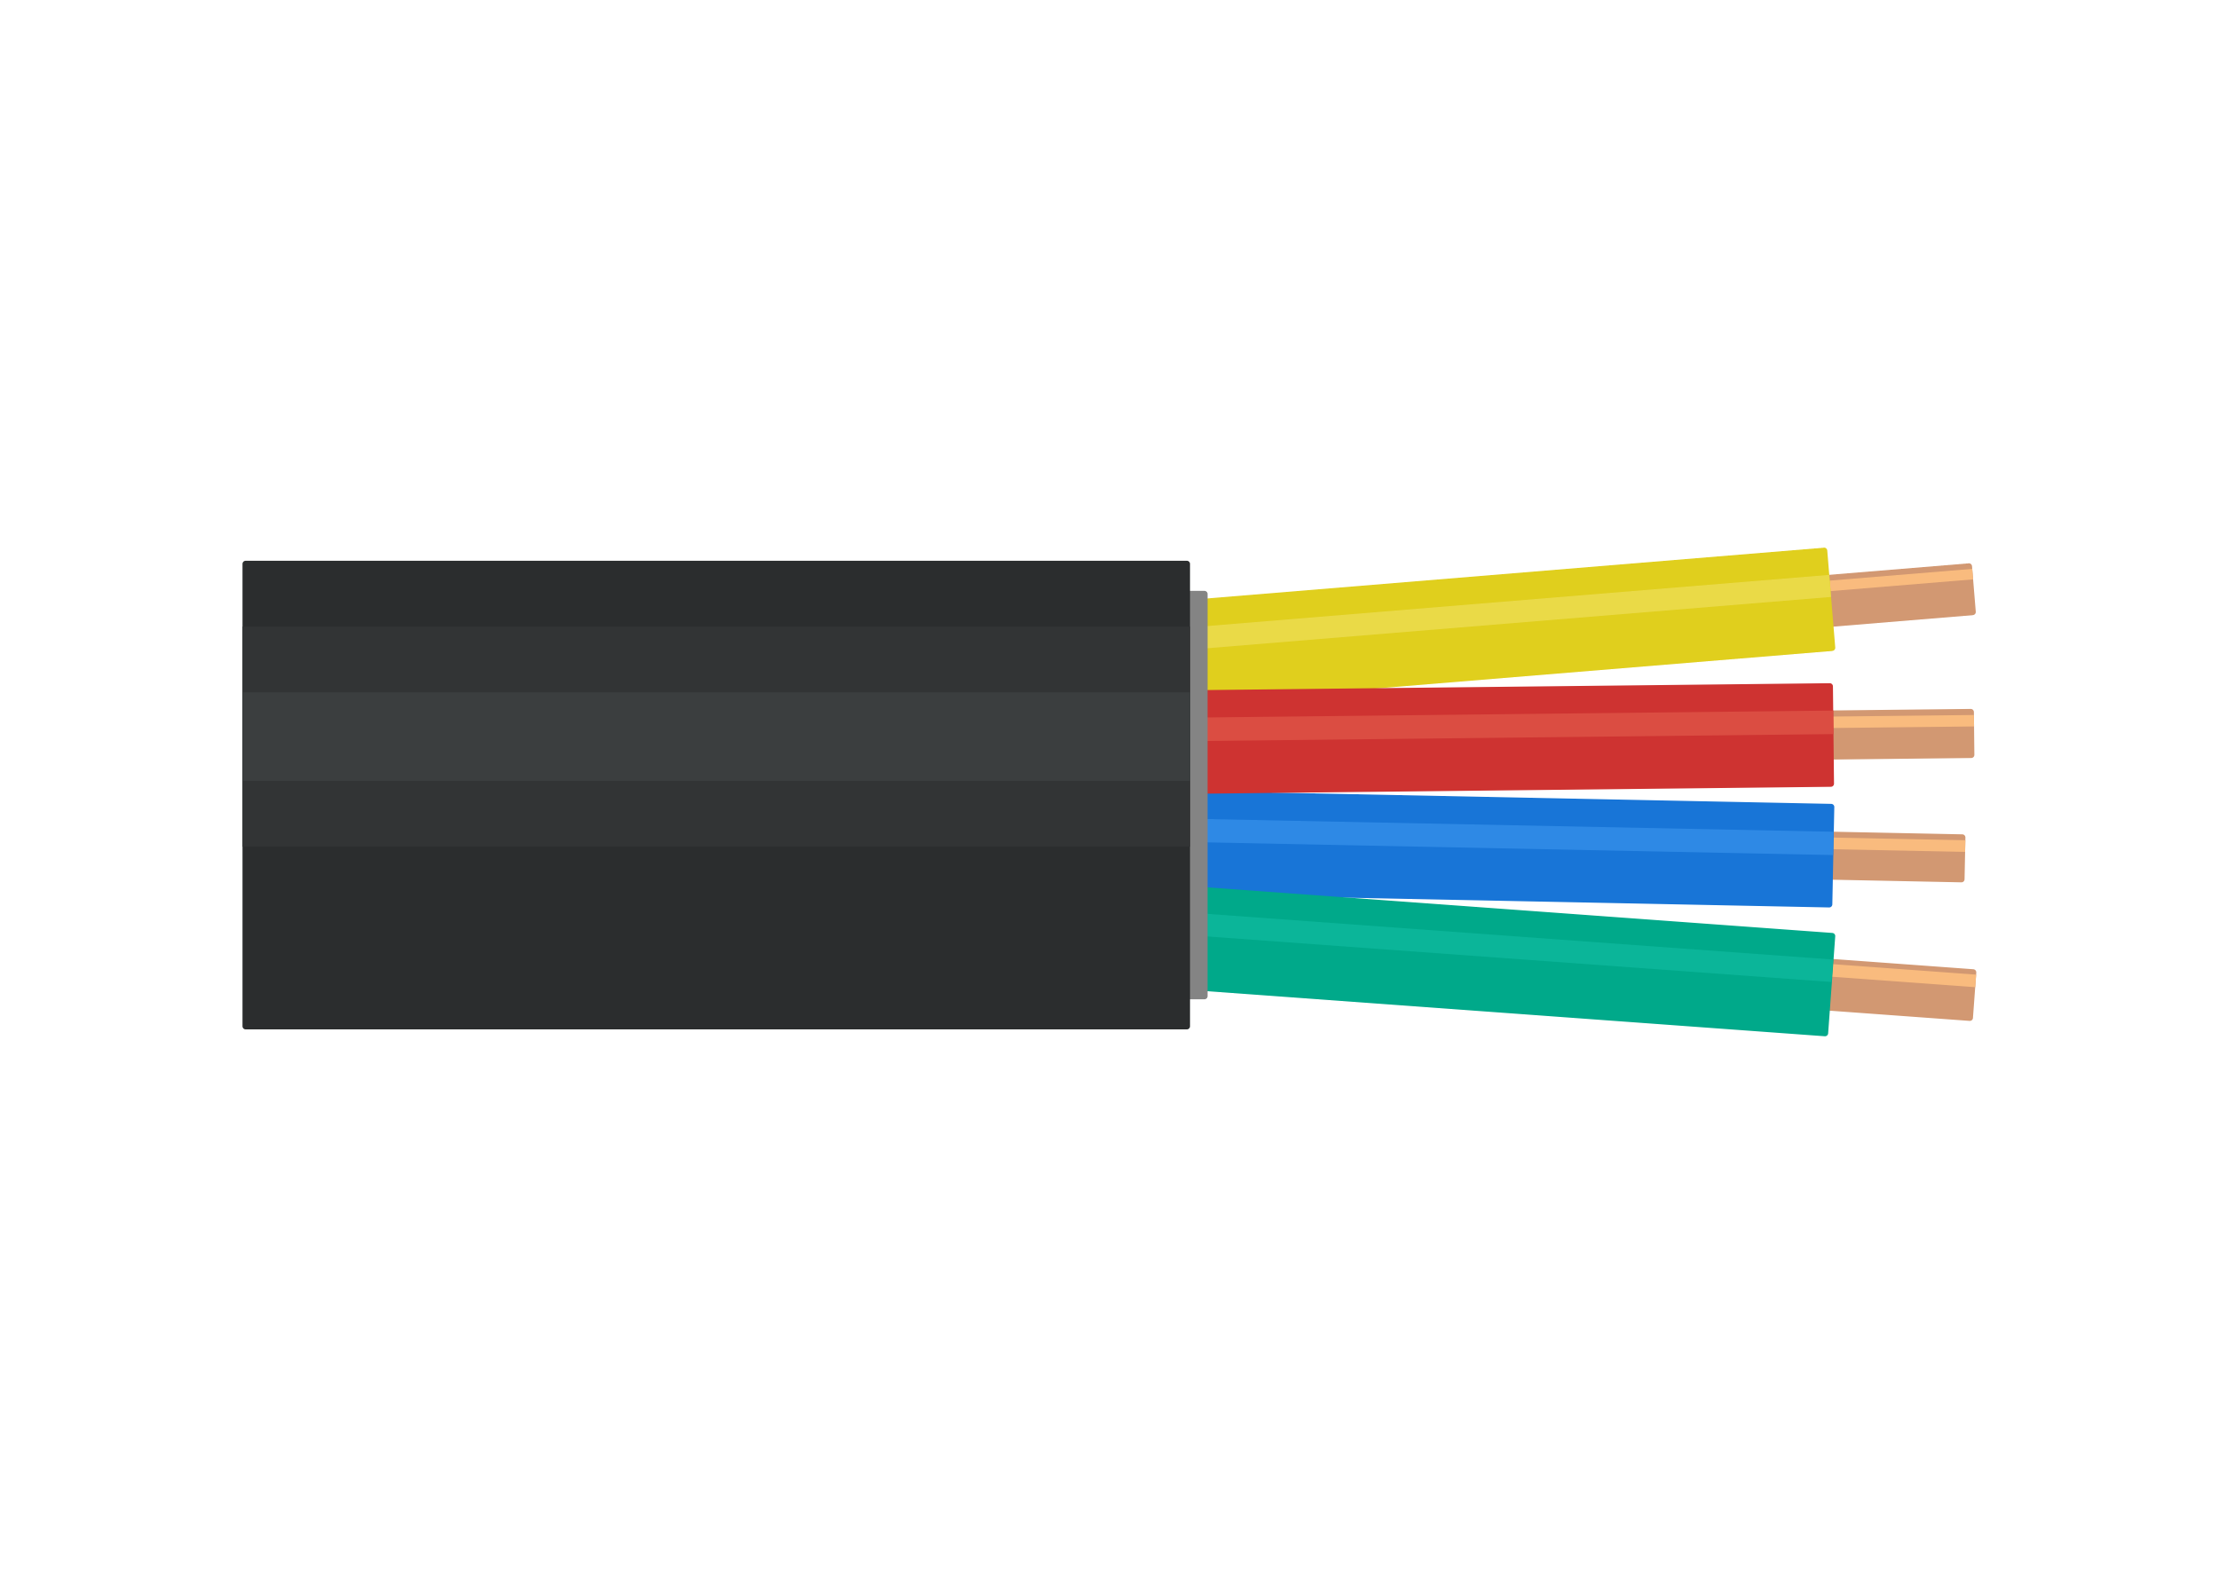 | : a connection made of tiny glass tubes that use light to pass information (Slide 24)
Protocols  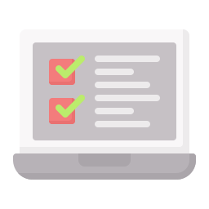 | : established rules that determine how data is transmitted (Slide 29)  : a number assigned to any device connected to the Internet  (Slide 29)  : an easy to remember address for calling a specific IP address (Slide 31)  : a service that translates URLs to IP addresses (Slide 31)
Thank you for joining us on an Amazon Future Engineer Career Tour!
Let us know how we did at https://amazon.com/careertoursurvey

