
AWS Data Center Tour 2:
Keeping Data Safe and Sustainable
Note Catcher
Name Class
The Big Question:
How does infrastructure in data centers keep data safe for customers and sustainable for the environment?
Directions: At each stop on the tour, match the new vocabulary word with its definition using the word bank below. At the end of each stop, reflect on what you learned about our investigation question.
water positive malware sensors infrastructure sustainability encryption
machine learning evaporation carbon zero cybersecurity redundancy carbon dioxide

Stop | Vocabulary | Facts I learned at this stop/  Questions I still have
My Selfies!


Keeping It Cool   | : the building and equipment that keep an operation running (Slide 7)  : the process where heat energy turns liquid into gas (Slide 9)

AWS Data Center Tour 2: Keeping Data Safe and Green Note Catcher

water positive malware sensors infrastructure sustainability encryption
machine learning evaporation carbon zero cybersecurity redundancy carbon dioxide

Stop | Vocabulary | Facts I learned at this stop/  Questions I still have
Back It Up   | : backup equipment that can be used if original equipment fails (Slide 14)  : hardware that take in information from the environment and trigger a response (Slide 16)
Security  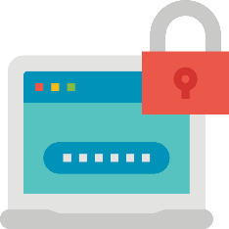 | : the protection of networks, data, and devices from unauthorized access or other digital threats (Slide 23)  : software designed to gain unauthorized access to a computer system (Slide 23)  : the science of getting computers to make their own predictions based on past data (Slide 23)  : scrambling data into a code that only authorized computers or users can access (Slide 23)
Sustainability  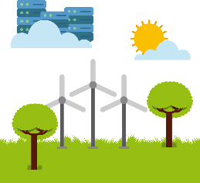 | : the ability to operate without depleting Earth’s resources and harming the environment (Slide 28)  : gas released from the burning of fossil fuels (Slide 28)  : not adding anymore carbon dioxide into the atmosphere from operating (Slide 30)  : returning more water to the community and environment than is used  (Slide 30)
Thank you for joining us on an Amazon Future Engineer Career Tour!
Let us know how we did at https://amazon.com/careertoursurvey

